***PAAREES PERFUMES***

***DAVIDOFF***

***FOR UNISEX***

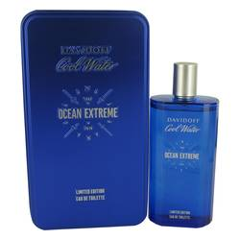

# *Cool Water Ocean Extreme*

***Description:***

Cool Water Ocean Extreme by Davidoff Cologne. Dive into a pool of refreshing aromas whenever you wear Cool Water Ocean Extreme cologne. Released in 2016, this fragrance invigorates and revives with its blend of fresh, aquatic ingredients. The composition begins with soft juniper berries, herbal rosemary, and frosty frozen mint. Cool and crisp, they instantly clear your mind. Salty sea notes are the star of the middle, joined by plush geranium, creamy sandalwood, and green lavender. Undertones of cedar and crystal musk support a final earthy note of seaweed. Wear this exhilarating cologne to feel energized and fresh throughout your day. Its light sillage makes it a great choice for daytime use.  
  
Swiss luxury goods brand Davidoff is known for its elegant accessories, including timepieces, pens, and eyewear. The company released its first fragrance in 1984. This cologne’s bottle is a deep, bright blue reminiscent of a clear ocean. It reflects the fresh, watery scents that lay within.